**Question**

ABC Ltd is a manufacturing company. The following cost information is available for its manufacturing business for next month.

|  |  |
| --- | --- |
|  | £ |
| Raw/direct materials | 20,000 |
| Direct labour | 25,000 |
| Depreciation of machinery | 2,000 |
| Factory rent & rates | 16,000 |
| Stores rent & rates. | 4,000 |
| Utilities | 1,000 |
| Insurance | 4,000 |
| Office and sales staff salaries | 9,000 |
| Logistics | 5,000 |

Using the above information illustrate your answer in the calculation of unit costs in accordance with marginal costing, absorption costing and activity-based costing methods. State any assumptions made in these calculations.

**Suggested solution**

**Marginal costing**

**Unit costs using marginal costing:**

Assumptions:

* Two similar products are produced, X and Y
* Total budgeted quantity for next month: 10,000 units; 4000 units of X and 6000 units of Y.

With marginal costing, the direct / variable production costs are the direct materials cost + direct labour costs.

Total direct / prime costs = £ [20,000 + 25,000] = £45,000

Unit cost for marginal costing = £45,000 / 10,000 units = £4.50

**Absorption costing**

**Unit costs using [traditional] absorption costing:**

Unit cost for absorption costing will include the direct costs and a share of the indirect production costs [or production / factory overheads]

Assumptions

* Two similar products are produced, X and Y
* Total budgeted quantity for next month: 10,000 units; 4000 units of X and 6000 units of Y.
* All production overheads assumed to be fixed production overheads [Office and sales staff salaries not production overheads and so are excluded]

Unit production cost for absorption costing

= marginal / variable /direct cost per unit + production overhead per unit.

Marginal / variable /direct cost per unit = £4.50

Production overhead per unit

= Total production overheads / Budgeted production quantity

Total production overheads = £32,000

Production overhead per unit = £32,000 / 10,000 units = £3.20

Unit production cost for absorption costing = £4.50 + £3.20 = £7.70

This production cost per unit of £7.70 under absorption costing assumes that both products, X and Y, are very similar and are produced using similar direct materials, direct labour resources and use the same production method. Hence both products are assumed to incur the same direct costs and production overheads per unit

**Unit costs using [traditional] absorption costing [an alternative approach] :**

Assumptions:

* Budgeted production quantity for next month is 10,000 units. This consists of 2 **similar** **products**: 4000 units of X and 6000 units of Y.
* Utilities and insurance costs are for ABC Ltd. The company is made up of 3 departments:

|  |  |  |  |
| --- | --- | --- | --- |
| Department | Factory | Administration | Sales |
| Number of employees | 50 | 60 | 18 |
| Floor space [square meters] | 1800 | 1400 | 800 |

The production cost per unit under absorption costing would be as follows:

* Direct or Marginal production costs per unit

= £45,000 / 10,000 units = £4.50 per unit

* Production/factory overhead per unit

Calculation of production/factory overhead per unit.

Total production/factory overhead = Depreciation of machinery + Factory rent and rates + Stores rent and rates + Logistics + Apportioned Utilities and Insurance

Total utilities and insurance for the company

= £ (1000 + 4000) = £5,000 per month

Utilities and insurance apportioned to the factory on the basis of floor space = £5,000 x [1800 / 4000] = £2250

Total production/factory overhead

= £ [2000 + 16000 + 4000 + 5000 + 2250] = £29,250

Production/factory overhead per unit = £29,250 / 10,000 units = £2.925 per unit.

Unit costs using absorption costing

= Direct or Marginal production costs per unit + Production/factory overhead per unit

= £4.50 + £2.925 = £7.425 per unit

Since both products are similar, both X and Y have the same unit cost of £7.425.

**Unit costs using activity-based costing [ABC]**

Assumptions:

* Budgeted production quantity for next month is 10,000 units. This is made up of 2 **similar** products: 4000 units of X and 6000 units of Y.
* Logistics costs of £5,000; logistics activity involves material processing costs. The cost driver for this activity is the number of material deliveries. The total number of material deliveries is 20 per month; 2 of these are for product X and 18 are for product Y.
* Utilities and insurance costs are for ABC Ltd which is made up of 3 departments as assumed in absorption costing.

The production cost per unit under activity-based costing would be as follows:

* Direct or Marginal production costs per unit

= £45,000 / 10,000 units = £4.50 per unit

* Production/factory overhead per unit [excluding logistics costs]
* Logistics costs per unit

Calculation of production/factory overhead per unit.

Total production/factory overhead = Depreciation of machinery + Factory rent and rates + Stores rent and rates + Apportioned Utilities and Insurance. Logistics costs are excluded here.

Total production/factory overhead

= £ [2000 + 16000 + 4000 + 2250] = £24,250

Production/factory overhead per unit = £24,250 / 10,000 units = £2.425 per unit.

Logistics costs are a total of £5000.

Logistics costs are driven by the number of material deliveries. The total number of material deliveries is 20; 2 of these material deliveries are for product X and 18 of them are for product Y.

Based on this information, the logistics costs per material delivery is:

£5000 / 20 deliveries = £250 per delivery.

Logistics costs allocated to product X = £250 x 2 deliveries = £500.

Logistics costs allocated to product Y = £250 x 18 deliveries = £4500.

Logistics costs per unit for each product:

X: £500 / 4000 units = £0.125 per unit

Y: £4500 / 6000 units = £0.75 per unit

The production cost per unit under activity-based costing (ABC) would be as follows:

* Direct or Marginal production costs per unit

= £45,000 / 10,000 units = £4.50 per unit

* Production/factory overhead [excluding logistics costs] per unit
* Logistics costs per unit

Production cost per unit

|  |  |  |  |  |
| --- | --- | --- | --- | --- |
|  | ABC | ABC | Absorption  Costing | Absorption  Costing |
| Product | X | Y | X | Y |
| Direct costs | £4.50 | £4.50 | £4.50 | £4.50 |
| Production overhead |  |  | £3.20 | £3.20 |
| - all except logistics | £2.425 | £2.425 |  |  |
| - logistics | £0.125 | £0.75 |  |  |
| Unit cost | £7.05 | £7.675 | £7.70 | £7.70 |

**Why do the two costing systems [Absorption costing and ABC] produce such different results?**

● Absorption costing simply allocates our entire amount of production overheads based on **one** absorption rate.

● ABC acknowledges that using one absorption rate as the basis for overhead allocation is not always appropriate: producing a product also involves a variety of production overheads which may be completely unrelated to the one absorption method used by absorption costing.

**Improved decision making with ABC**

Due to the improved costing information provided by ABC, we are able to implement a number of strategies that will enable us to reach our goal of increasing profitability.

Business

|  |  |  |  |
| --- | --- | --- | --- |
|  | **ABC profit-increasing strategies** | |  |
|  | **Pricing** | Increase the selling price to make it profitable. If X it costs you £7.05 to make & sell it for at least £7.06 and you'll always make profit on the products you sell! |  |
|  | **Cost driver analysis** | Investigate more efficient methods of materials processing in order to reduce cost. |  |
|  | **Review production process** | Determine whether the high amount of materials processing is necessary. |  |
|  | **Change product mix** | Consider if we should discontinue production of certain models/products and concentrate on the already profitable models. |  |

**Advantages and disadvantages of ABC**

The full benefit of using ABC over traditional absorption costing can only be experienced when conditions are favourable. ABC is most effective where:

● A diverse product range is being produced and items are produced in small batches and in environments where the method of producing each product is different

● Overhead costs are high in comparison to direct costs, e.g. the service sector

● Costs are not driven by volume, but instead by things such as complexity of product or level of customisation.

**Advantages of ABC**

|  |  |  |  |  |
| --- | --- | --- | --- | --- |
|  |  | | |  |
|  | **Improved pricing** | | With ABC, managers have a more accurate indication of how much a product actually costs to make. |  |
|  | **Improved cost control** | | By identifying cost pools and their drivers, management has a greater ability to pinpoint inefficiencies and address them. |  |
|  | **Improved product mix** | | ABC helps us optimise our product mix by determining which of our products is most profitable. |  |
|  | **Improved profitability analysis** | | With more accurate costing information comes improved profitability analysis our products, our customers and our overall operation. |  |
| **Disadvantages of ABC** | | | | |
| **Cost** | | Breaking down products and their production process is both time consuming and expensive, which can stop ABC from being viable. | | |
| **Not always suitable** | | ABC is of limited benefit if overhead costs are low or are mainly volume related, if only one product is being produced or if every product is produced in a similar way. | | |
| **Not required by IAS** | | International Accounting Standard [IAS] only requires an ‘appropriate’ amount of absorption of fixed overhead. | | |

**Comparing the costing systems**

The absorption and marginal costing systems have a number of advantages and disadvantages. Understanding these is essential to utilising them fully.

|  |
| --- |
| Absorption costing: |
| * Required by financial accounting |
| * Ensures all costs recovered |
| * Involves approximation for overheads |
| * Not suitable for decision making |

|  |
| --- |
| Marginal costing: |
| * Focuses on contribution which drives profitability |
| * Allows for flexibility in pricing |
| * Enables identification of break even and margin of safety |
| * Income statement is more realistic than absorption costing as profit changes match volume changes |

|  |
| --- |
| However, marginal costing has the following limitations |
| * Not acceptable for valuation of inventory for financial accounting purposes |
| * May encourage low selling prices |
| * Fixed costs may not be covered |

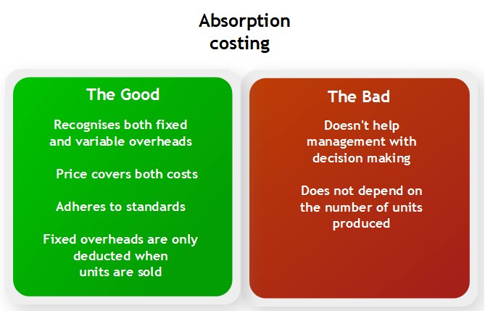

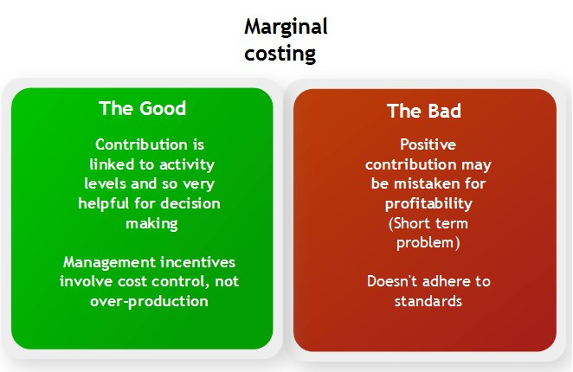

**Additional notes on Activity based costing**

**Activity based costing (also known as ABC)** provides a more accurate method of allocating costs in a modern manufacturing environment compared to the traditional costing system using absorption costing.

In today’s world, direct labour costs make up less of the total costs, whilst overheads are even more significant. We need to consider how the costs are absorbed and if we’re doing it in a way that gives a true indication of how the costs are incurred.

ABC recognises that production overheads are incurred through specific activities rather than production volume. ABC focuses on the causes of costs and not their cost behaviour. The means it is not whether a cost is a fixed or a variable cost but what causes the cost to change.

With ABC, the company’s activities are analysed into groups of costs, one group for each major activity. These groups are called cost pools. Factors are identified that cause the costs to change. These factors are called cost drivers. The cost of the output is then calculated according to the output’s level of activity.

The cost rate per activity is calculated: Cost pool / Cost driver

Examples of activity, cost pools, cost drivers and cost rate are as follows:

|  |  |  |  |
| --- | --- | --- | --- |
| Activity | Cost pools | Cost driver | Cost rate |
| Receiving raw materials into stores | Cost of receiving the raw materials into the stores | Number of deliveries into stores | Cost of receiving the raw materials / Number of deliveries |
| Setting up production equipment | Cost of setting up production equipment | Number of set-ups carried out | Cost of setting up / Number of set-ups |

From the above, it is clear that more activity, causes or drives more costs/overheads to be incurred. So, for example, if an order or product requires 10 requisitions then 10 times the requisition costs are allocated to that order or product. Hence ABC directly links the activity to the related overheads